Mestvinnende havanais 2013

Tisper

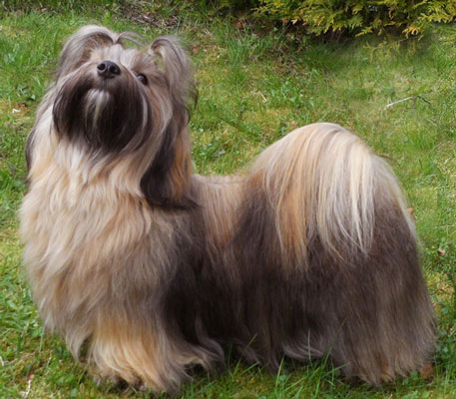 | Happy Friend's Zouvenir | Frøydis Monsen | 12+28+17+10+26 | 93
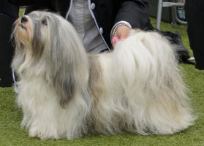 | NUCH Skystar’s Alicia | Hege Mokkelbost | 11+10+13+10+11 | 55
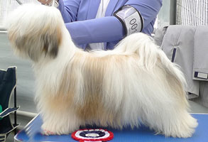 | Jatakabi’s Kind Of Magic | Anne-Cathrine Unelsrød | 10+9+11+10+11 | 51
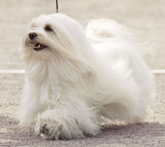 | NUCH Lekkerbisken's Miss Quality | Bente Mikkelsen | 9+9+9+11+11 | 49
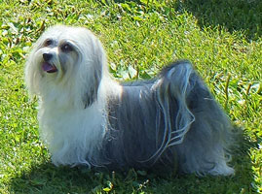 | Bamse's Noblesse | Wenche Sørestrømmen | 9+10+10+7+12 | 48
 | Toy-Fozzie's Cuban Delicious Emma | Anne Herseth | 10+6+7+10+10 | 43
 | Kjeken’s Caja | Dagfinn Fosen | 8+6+9+8+11 | 42
 | N SE UCH NV-06 NVV-11-12 Ting-Ge-Lings Little Sweetheart | Heidi Hoberg | 11+21+8 | 40
 | NUCH NORDJV-11 NJV-11 Ting-Ge-Lings Be My Bertha | Heidi Hoberg/Ulf Meyer | 7+8+9+9 | 38
 | Lekkerbisken’s You Win It | Elin Isaksen | 18+3+8+8 | 37
 | Lekkerbisken's Walk Of Fame | Silje K. Couling-Aas | 7+10+10+10 | 37

